**Dimensional Sinbad**

1. ***Basic Info***

* Game Name: Dimensional Sinbad
* Team Name: Persona
* Members: Geshev, Zhang, Lu
* Genre: Puzzle + Action
* Description: The Dimensional Sinbad is a game which encourages the player to switch the scene between 2D and 3D to solve the puzzles and kill the enemies. The target of the game is to control the Sinbad to get to the green block while avoiding the red block and killing the enemies. Some blocks seem to be unreachable in 3D scene, and if the player switches to 2D scene, there might be some surprises waiting for the player. ☺
* Screenshot:

3D space:

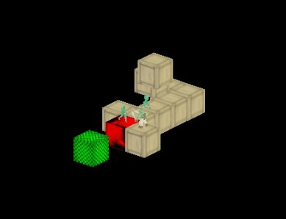

2D space:

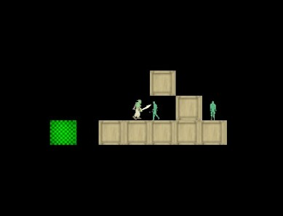

1. ***Project Team Plan***
2. 1st meeting: discussed the idea of the game, and separated the basic parts of the code for each group member.
   1. Lu: the control of the movements and the animations for the player.
   2. Zhang: the blocks, which has 3 kinds of status.
   3. Geshev: the camera and perspective controls.
3. 2nd meeting: separated the higher jobs for every group member.
   1. Lu: the enemies and the enemies’ manager which takes control of all the enemies.
   2. Zhang: XML support which is used to record the levels and the enemies.
   3. Geshev: transition of the Sinbad between 2D and 3D perspective, level reload, next level, etc.
4. 3rd meeting: complete the whole game.
5. 4th meeting: collect the testing data and debug.
6. ***Vision Statement***
7. ***Features of the Game***

There are three most important features in this game.

1. Core Features
2. 2D or 3D perspective?

As the most important feature in this game, perspective-change is the core and the interesting point of the game, the player has to change the perspective to get to the destination/avoid enemy etc. The player has to use the imagination to get the Sinbad to the destination safe and sound.

1. Block creating

Blocks are the platforms the player can move on.

1. Player moving

Player can turn and move according to the camera’s position

1. Secondary features
2. Red blocks

Red blocks are forbidden, the player cannot walk onto it, and else game is over.

1. Golden Knot?

Golden Knots consist the score! Go get them! We use such formula to calculate the score: $\sum{{GoldenKnot[i]}/{TimePassedSinceStart}}$ so, go get them as soon as you can!

1. Attacking!

Have you seen those ninjas? They are the enemies who will make you lose the fight! Go fight them as soon as you can! Also, we have the formula to calculate the score too: $\sum{{Enemy[i]}/{TimePassedSinceStart}}$ so, kill them as soon as you can!

1. ***Tool Used and Why***
2. Visual Studio

This is the main developing tool for the whole project.

1. SVN (with support of code.google.com)

This is used to synchronize the version of the codes for every member in the team.

1. XML

Due to that this game is a multi-level game, we need some scripts to record the level data, and thus the XML is a very good choice for us to store the level data

1. ***Iterations***
   1. Iteration 1

In Iteration 1, we implement only one level with the some hard-coded blocks, the player can move in basic animations, and the camera has 4 views and can adjust itself automatically. The hard-coded enemies are implemented also.

We have some people to test the game, and conclusion is that if we don’t have a tutorial to teach the player how to play, they would not know what to do with these features.

* 1. Iteration 2

In Iteration 2, the XML reader is implemented, and we place all the hard-coded data into the XML to store. We also implement the top view so Sinbad can move in upper and lower blocks. Green and red blocks are added, gold is also added.

Due to we implement the features too fast, there are many bugs still existed. We spent lots of time debugging.

1. ***Demo of the Project***
2. ***What You Have Learned from the Project?***
   1. Kiril Geshev
   2. Xiaoxuan Zhang
   3. Yufan Lu

In this project, I found that if a